BRITISH ACADEMY OF AUDIOLOGY

Scope of Practice: Audiology Professionals

(DRAFT)

October 2024

Contents
1 Background 2
1.1 Acknowledgements 2
1.2 General considerations 2
2 Section A: Who is an audiology professional? 4
2.1 Introduction 4
2.2 Role 4
2.2.1 Definition 4
2.2.2 Role Description 4
2.2.3 Key Tasks and Activities 4
2.2.4 Employing Audiology Professionals. 6
2.2.5 What if there is a problem? 6
3 Section B - Good audiological practice. 7
3.1 Knowledge, skills & performance 7
3.1.1 Your own health and patient safety 7
3.1.2 Indemnity Arrangement 7
3.1.3 Fulfil all professional requirements 7
3.1.4 Respond to any complaints made against you professionally 8
3.2 Safety and quality 8
3.2.1 Responsibility for quality systems 8
3.2.2 Raising Concerns 8
3.3 Communication partnership and teamwork 9
3.3.1 Delegation of Tasks 9
3.4 Maintaining trust 9
3.4.1 Bullying or harassment 9
3.4.2 Uphold your position as an Audiologist and Hearing Health professional. 9
4 Section C: Career Framework 11
4.1 Introduction 11
5 Appendices 13

Background

Acknowledgements
TBC
This guidance document was developed by the BAA Education portfolio, consisting of professionals drawn from across sectors and specialisms. It will be reviewed regularly and revised as needed to reflect developments in audiology.

General considerations
Across UK healthcare professions there is no single definition of what constitutes a scope of practice document, partly driven by variation in legislation and registration across the professions. Additionally, there is no single regulatory body for all audiology professionals working in the UK. The regulatory body for audiologists working in the NHS, the Academy of Healthcare Science (incorporating the Registration Council for Clinical Physiologists), remains voluntary. In contrast, audiology professionals working in the private sector are required to register with the Health & Care Professions Council.

This renders the task of re-developing the BAA Scope of Practice (ScoP) Document particularly challenging. Equally, it underlines the requirement for a unified scope of practice document for all audiology professionals across sectors.

To ensure the BAA ScoP effectively meets this requirement, the document has been designed and assessed using the regulatory principles defined by Leslie et al., (2021). Nonetheless, the BAA is not a regulatory body, so the ScoP will be shared with a stakeholder group that includes other audiology professional and regulatory bodies, to ensure that it is both fit for purpose and effectively utilised by regulatory bodies in conjunction with their professional standards.
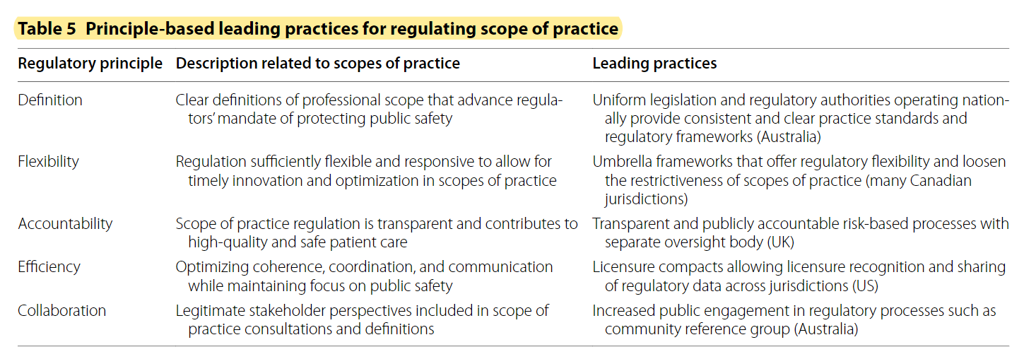
Figure 1 Taken from the Leslie et al., (2021) analysis of leading practices related to regulating scopes of practice across the US, Canada, UK and Australia.
The aims of this document are as follows:
- Defining extent and limits of practice for an audiologist.
- Establishing the principles of good audiological practice which all audiologists must adhere to, regardless of career framework level or sector, to ensure patient safety.
- Identifying minimum levels of clinical capabilities according to career level and/or context.

To achieve these aims, the document has been split into 3 sections. Section A: Who is an audiologist? defines the clinical and professional capabilities of an audiologist. Section B: Good Audiological Practice Guide outlines expectations of audiologists in practice, including (i) knowledge, skills & performance, (ii) safety and quality, (iii) communication partnership and teamwork and (iv) maintaining trust, and Section C: Career Framework links career levels to capabilities,

Section A: Who is an audiology professional?

Introduction
The British Academy of Audiology (BAA) is the professional body which represents Audiology Professionals who may be registered with the Health & Care Professions Council (HCPC) or the Academy of Healthcare Scientists (AHCS).
The guidance in this document reflects best practice at the time of publication. It provides a framework for BAA members to use to define Audiology Professional’s roles within their services.
The document describes the Audiology Professional’s role in terms of:
- tasks which could be undertaken by an Audiology Professional.
- the Audiology Professional’s role along the patient / client Pathway
- training programmes
- responsibilities of BAA, the employer and the Audiology Professional.

Role

Definition
An Audiology Professional is an employed, registered, trained service provider who can undertake a range of activities within Audiology service delivery in order to diagnose and treat hearing and balance disorders. An Audiology Professional will focus on patient / client ear and hearing health supporting their needs by providing, advice, diagnostic, therapeutic and rehabilitative ear and hearing care. The Audiology Professional will comply with standards that ensure best practice and continuous improvement.

Role Description
An Audiology Professional is described as someone who:
- is a healthcare worker who has the attitudes, skills and knowledge to provide a range of agreed tasks and activities to provide safe and effective balance or hearing care support within defined levels of competency.
- has undergone an approved training programme (see the British Academy of Audiology website for training programmes).

Key Tasks and Activities
The central focus of their work is to provide and enhance the Audiology services to patients/ clients.
After successful completion of accredited training programmes, the Audiology Professional’s activities may include:
- effective communication with patients / clients and their relatives or carers.
- the provision of general information to clients about currently available Audiology Services.
- accurate recording of client information contributing to a case history.
- obtaining informed consent from the patient / client for any intervention.
- the performance of routine audiological diagnostics for adult patient /clients in accordance with current recommended procedures.
- the performance of routine audiological diagnostics for child patient /clients in accordance with current recommended procedures.
- the performance of objective audiological measurements for adult and child patients /clients in accordance with current recommended procedures and for the purpose of detailed or specific diagnosis.
- the performance of balance & vestibular function measurements for adult and child patients /clients in accordance with current recommended procedures and for the purpose of detailed or specific diagnosis.
- assessment of tinnitus & hyperacusis and therapy as set out in a management and rehabilitation plan agreed with the patient / client / carer.
- advice to patients / clients on earwax management and wax removal.
- taking aural impressions in accordance with current recommended procedures for the provision of earmoulds or other custom-made devices and ear fittings.
- the fitting of hearing aid systems to adults (including subjective and objective evaluation of aid performance and effectiveness and teaching the patient / client how to fit, to use and to care for hearing aids) as set out in a management and rehabilitation plan agreed with the patient / client.
- the fitting of hearing aid systems to children (including subjective and objective evaluation of aid performance and effectiveness and teaching the patient / client / carer how to fit, to use and to care for hearing aids) as set out in a management and rehabilitation plan agreed with the patient / client / carer.
- the fitting of implantable hearing aid systems to children and adults (including subjective and objective evaluation of aid performance and effectiveness and teaching the patient / client / carer how to fit, to use and to care for hearing aids) as set out in a management and rehabilitation plan agreed with the patient / client / carer.
- the understanding and practice of autonomous decision making within a scope of competence.
- ensuring that the varied needs of individual patients / clients are recognised and included in any individual management plan.
- the recognition of where there is the need for advice and management from the other professionals in health and social care
- the ability to work co-operatively with other professionals in health and social care in the management of care plans for individual patients/clients.
- ensuring delivery and practice is supported by evidence based critical thinking and governed by principles of continuous improvement.

- maintaining competence and broadening scope of practice with continuous professional development.

- ensuring human relations and leadership skills are compatible with the working environment and career framework.

- taking responsibility for patient / client outcomes and service quality.

- act in an honest and ethical manner in line with the requirements of professional regulatory bodies.

Employing Audiology Professionals.
In employing Audiology Professionals to carry out some or all of the tasks identified above, the employer must ensure the employee has undergone the appropriate training, supervision and has a programme of continuing professional development to maintain and develop competence.

What if there is a problem?
As a professional body, the BAA has a role to support its members and promote the profession. There are a number of instances when a member may wish to seek BAA advice or support.
The following examples are given by way of illustration and do not signify the necessity of involving BAA or the limits of BAA involvement in any one case.
- Tasks outside role
  - If an Audiology Professional is concerned that they are being asked to undertake tasks which sit outside their role should first approach their employer using the BAA role description as a basis for discussion.
  - If the matter persists, members of BAA can contact BAA directly for guidance and support, and are encouraged to escalate within their organisation where appropriate.
- Audiology Professional Competence
  - If the on-going competence of an Audiology Professional is a concern, it is the responsibility of an Audiology Professional to address and resolve the area of concern, in order for the individual to continue to act in the role.
  - Audiology Professionals can use the BAA role description and the plus the national codes of conduct as an objective measure of performance to enable the area of concern to be described and named, so that appropriate action might be taken.
  - Any competence issues must be addressed as soon as they are detected, and where an organisation has capability policies in place to support returning to competence, these should be adhered to.
- Support for Students in Training
  - The responsibility for supporting a student in training is shared between the training provider and the employer. As part of regulatory requirements in the approvals process, training providers are asked to outline their procedures to support students in all aspects of the training.
  - If the training provider or the employer does not meet the regulatory standards required during their training, then the student will be able to seek advice from the BAA and their regulatory body.

Section B - Good audiological practice.
In this section of the scope of practice we set out the areas that each professional regardless of role, occupational setting or experience within their profession should achieve. These are aligned to the Good Scientific Practice standards issued by the Academy of Healthcare Science and the Standards of Conduct, Performance and Ethics produced by the Health & Care Professions Council.
The responsibility for maintaining good professional practice rests with every individual within the audiology sector and relates to many areas of professional behaviour. Personal responsibility for professional behaviour must be upmost in our minds to maintain public trust in the profession.
This section is separated into areas that all contribute to good audiological practice.

Knowledge, skills & performance

Your own health and patient safety
- If you know or suspect that you have a serious condition that you could pass on to patients, or if your judgement or performance could be affected by a condition or its treatment, you must inform Occupational Health staff if available, or your own General Practitioner for advice on practising safely.
- You must follow their advice about any changes to your practice they consider necessary. If appropriate you should inform your registration body of any changes to your practice that may affect your ability to remain on the register.

Indemnity Arrangement
- As an audiologist you should make sure that you have an appropriate indemnity arrangement in place relevant to your scope of practice and work setting.
- This indemnity should meet the requirements of your professional registration body.

Fulfil all professional requirements
To achieve this, you must:
- Keep your knowledge and skills up to date, taking part in appropriate and regular learning and professional development activities that aim to maintain and develop your competence and improve your performance.
- Cooperate with requests to act as a witness in any hearing that forms part of an investigation, even after you have left the profession.
- Inform your registration body and any employers as soon as you can about any caution or charge against you, or if you have received a conditional discharge in relation to, or have been found guilty of, a criminal offence (other than a protected caution or conviction).
- Tell any employers you work for if you have had your practice restricted or had any other conditions imposed on you by your registration body.
- Tell your employers and registration body at the first reasonable opportunity if you are or have been disciplined by any regulatory or licensing organisation, including those who operate outside of the professional health and care environment..

Respond to any complaints made against you professionally

- Never allow someone’s complaint to affect the care that is provided to them.
- Use all complaints as a form of feedback and an opportunity for reflection and learning to improve practice.
- Provide leadership to make sure people’s wellbeing is protected and to improve their experiences of the health and care system.
- Identify priorities, manage time, staff, and resources effectively and deal with risk to make sure that the quality of care or service you deliver is maintained and improved, putting the needs of those receiving care or services first.

Safety and quality
- Attention by each individual practitioner to safety and quality puts the interests of patients and service users first and promotes trust through professionalism.
- You should aim to always practise in line with the best available evidence.
- Make sure that any information or advice given is evidence-based including information relating to using any health and care products or services.
- To maintain quality, you must maintain the knowledge and skills you need for safe and effective practice.
- To ensure the safety and quality of your work can be assessed and audited you should keep clear and accurate records relevant to your practice.

Responsibility for quality systems
- You must take part in systems of quality assurance and quality improvement to promote patient safety.
- Taking part in regular reviews and audits of your work and that of your team.
- Respond constructively to the outcomes, of reviews and audits.
- Take steps to address any problems identified in reviews and audits and carry out further training where necessary.
- You should regularly reflect on your standards of practice and the care you provide, including reviewing patient feedback where it is available.

Raising Concerns
- Act without delay if you believe that there is a risk to patient safety or public protection.
- You should raise and, if necessary, escalate any concerns you may have about patient or public safety, or the level of care people are receiving in your workplace or any other health and care setting which you have direct involvement with. Using the channels available to you in line with our guidance, the guidance of your registration body and your local working practices.
- You should raise your concerns immediately if you are being asked to practise beyond your role, experience, and training.
- You should acknowledge and act on all concerns raised to you, investigating, escalating, or dealing with those concerns where it is appropriate for you to do so.
- You should not obstruct, intimidate, victimise or in any way hinder a colleague, member of staff, person you care for or member of the public who wants to raise a concern.
- You must take prompt action if you think that patient safety, dignity, or comfort is being compromised.

Communication partnership and teamwork

Delegation of Tasks
- You remain accountable for your decisions to delegate tasks and duties to other people.
- You must only delegate tasks and duties that are within the other person’s scope of competence, making sure that they fully understand your instructions.
- You must make sure that everyone you delegate tasks to is adequately supervised and supported so they can provide safe care.
You should confirm that the outcome of any task you have delegated to someone else meets the required standard,

Maintaining trust

- You are personally accountable for your professional practice and must always be prepared to justify your decisions and actions.
- In addition, you must always uphold the reputation of your profession.
To achieve this, you must:
- Keep to and uphold the standards and values set out in the Code of Conduct of your registration body.
- Act with honesty and integrity always, treating people fairly and without discrimination,

Bullying or harassment
- Be aware at all times of how your behaviour can affect and influence the behaviour of other people.
- Treat people in a way that does not take advantage of their vulnerability or cause them upset or distress.
- Stay objective and always have clear professional boundaries with people in your care (including those who have been in your care in the past), their families and carers.
- Ensure that your personal beliefs (including political, religious, or moral beliefs) are not expressed to people inappropriately.
- Act as a role model of professional behaviour for students and newly qualified health professionals and support staff to aspire to good professional practice.
- Use all forms of spoken, written and digital communication (including social media and networking sites) responsibly, always respecting the right to privacy of others.

Uphold your position as an Audiologist and Hearing Health professional.

To achieve this, you must:
- Act with honesty and integrity in any financial dealings you have with everyone you have a professional relationship with, including people in your care.
- Make sure that any advertisements, publications, or published material you produce or have produced for your professional services are accurate, responsible, ethical, do not mislead or exploit vulnerabilities and accurately reflect your relevant skills, experience, and qualifications.
- Cooperate with the media only when it is appropriate to do so, and then always protecting the confidentiality and dignity of people receiving treatment or care.

Section C: Career Framework

Introduction
A career framework supports staff long-term development in a structured way. In some ways it sits outside of a scope of practice document because an individual’s scope of practice is independent of their job description.
Scope of practice is the limit of an individual’s knowledge, skills and experience and is made up of the activities they carry out within your professional role. It applies to everyone working within an audiology service whether NHS or private sector. As a health and care professional, individuals must keep within their scope of practice at all times to ensure they are practising safely, lawfully and effectively. This is likely to change over time as their knowledge, skills and experience develop.
Your scope of practice is not the same as your roles and responsibilities as defined in your job description. Your scope of practice may not be equal across all areas of audiology. There may be times when your scope of practice exceeds the roles and responsibilities of your job description; at other times your job description may contain elements that are outside of your scope of practice. It is everyone’s responsibility to work within their scope of practice and via continued professional development (CPD), identify areas that are outside of their scope of practice that will require training or educational support. Individuals are expected to address these areas before performing those skills autonomously and complete a competency assessment if required. CPD will also be required to maintain an individual’s knowledge and skills within your scope of practice; professionals must adhere to the specific CPD requirements of your regulatory body.
Scope of practice sits within the Professional Practice domain of Good Scientific Practice (GSP). GSP defines five domains that are inter-linked and scope of practice applies to each of these domains:
- Professional Practice
- Scientific Practice
- Clinical Practice
- Research Development and Innovation
- Clinical Leadership
Each domain applies to every level of a career framework. The HCPC offers advice regarding defining your scope of practice: Identifying your current scope of practice | (hcpc-uk.org).
Audiology services use a wide variety of job titles which may fit with national profiles or be specific to an individual service provider, therefore job titles do not necessarily correlate with role and are weak indicators of scope of practice. This document therefore will avoid describing roles solely by titles but will provide common titles as illustration.
Individuals are likely to progress between career framework levels in a gradual basis by continual development of their skills, knowledge and practice in each of the domains.

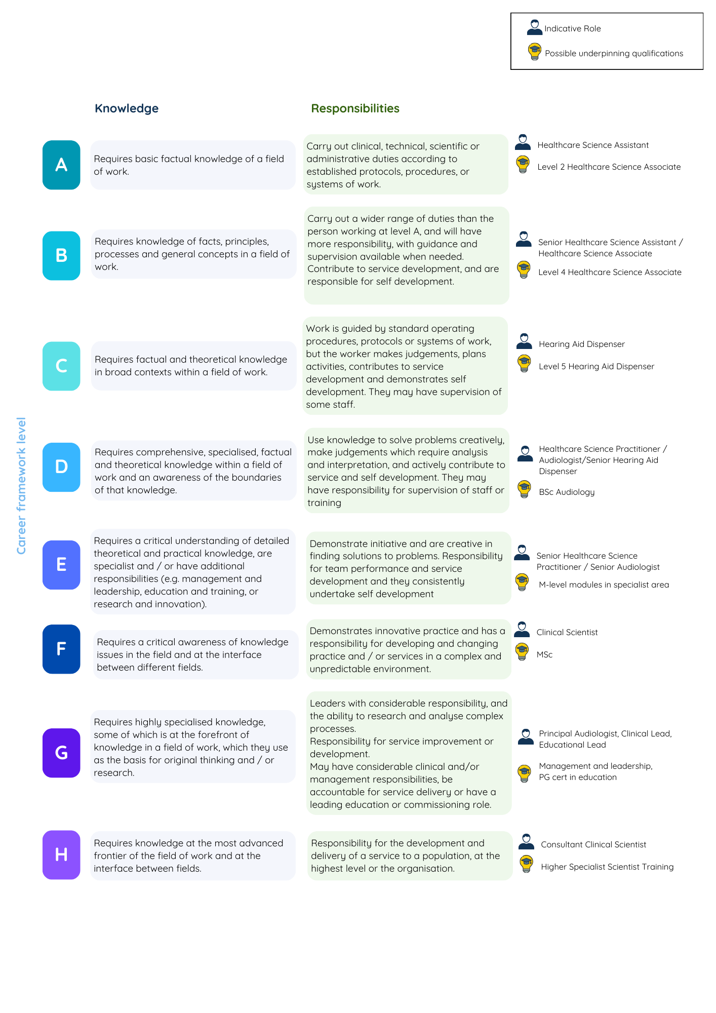
Figure 2: Career Framework based on HEIW document Professional Framework for Enhanced, Advanced and Consultant Clinical Practice in Wales.

Appendices
[Example profiles for each career framework level to be included here. Not included in the version for consultation.]

Leslie, K., Moore, J., Robertson, C. et al. Regulating health professional scopes of practice: comparing institutional arrangements and approaches in the US, Canada, Australia and the UK. Hum Resour Health 19, 15 (2021). https://doi.org/10.1186/s12960-020-00550-3
This document relates to educational/skill levels and not relate to agenda for change pay scales.
Now incorporating the Registration Council for Clinical Physiologists (RCCP)
Although registration with AHCS remains voluntary, it is the British Academy of Audiology’s position that audiologists should maintain registration to demonstrate a commitment towards professional standards and continuing professional development.
https://www.ahcs.ac.uk/education-training/standards/
https://www.hcpc-uk.org/standards/standards-of-conduct-performance-and-ethics/

